Experiment 5:
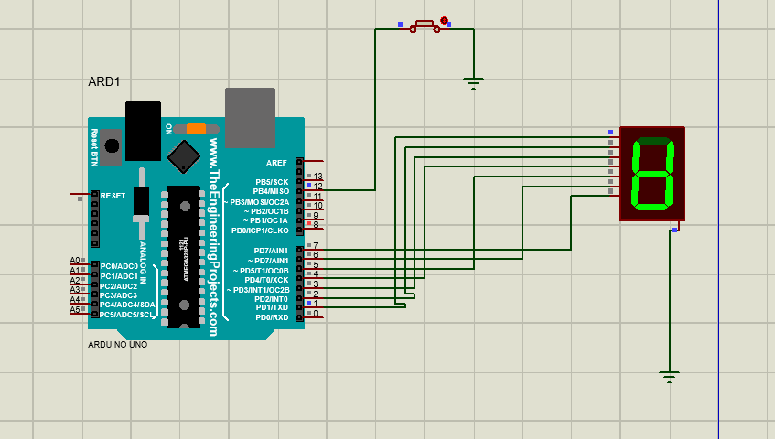
Source code:
// Arduino Manual Electronic Counter
// Push Button -> Pin 12
// 7-Segment Display (Common Cathode)
const int buttonPin = 12;
const int a = 2;
const int b = 3;
const int c = 4;
const int d = 5;
const int e = 6;
const int f = 7;
const int g = 8;
int count = 0;
int lastButtonState = HIGH;
void setup()
{
pinMode(buttonPin, INPUT_PULLUP);
pinMode(a, OUTPUT);
pinMode(b, OUTPUT);
pinMode(c, OUTPUT);
pinMode(d, OUTPUT);
pinMode(e, OUTPUT);
pinMode(f, OUTPUT);
pinMode(g, OUTPUT);
displayDigit(0);
}
void loop()
{
int buttonState = digitalRead(buttonPin);
if(buttonState == LOW && lastButtonState == HIGH)
{
delay(200); // Debounce
count++;
if(count > 9)
count = 0;
displayDigit(count);
while(digitalRead(buttonPin)==LOW);
}
lastButtonState = buttonState;
}
void displayDigit(int digit)
{
switch(digit)
{
case 0: zero(); break;
case 1: one(); break;
case 2: two(); break;
case 3: three(); break;
case 4: four(); break;
case 5: five(); break;
case 6: six(); break;
case 7: seven(); break;
case 8: eight(); break;
case 9: nine(); break;
}
}
void zero()
{
digitalWrite(a,HIGH);
digitalWrite(b,HIGH);
digitalWrite(c,HIGH);
digitalWrite(d,HIGH);
digitalWrite(e,HIGH);
digitalWrite(f,HIGH);
digitalWrite(g,LOW);
}
void one()
{
digitalWrite(a,LOW);
digitalWrite(b,HIGH);
digitalWrite(c,HIGH);
digitalWrite(d,LOW);
digitalWrite(e,LOW);
digitalWrite(f,LOW);
digitalWrite(g,LOW);
}
void two()
{
digitalWrite(a,HIGH);
digitalWrite(b,HIGH);
digitalWrite(c,LOW);
digitalWrite(d,HIGH);
digitalWrite(e,HIGH);
digitalWrite(f,LOW);
digitalWrite(g,HIGH);
}
void three()
{
digitalWrite(a,HIGH);
digitalWrite(b,HIGH);
digitalWrite(c,HIGH);
digitalWrite(d,HIGH);
digitalWrite(e,LOW);
digitalWrite(f,LOW);
digitalWrite(g,HIGH);
}
void four()
{
digitalWrite(a,LOW);
digitalWrite(b,HIGH);
digitalWrite(c,HIGH);
digitalWrite(d,LOW);
digitalWrite(e,LOW);
digitalWrite(f,HIGH);
digitalWrite(g,HIGH);
}
void five()
{
digitalWrite(a,HIGH);
digitalWrite(b,LOW);
digitalWrite(c,HIGH);
digitalWrite(d,HIGH);
digitalWrite(e,LOW);
digitalWrite(f,HIGH);
digitalWrite(g,HIGH);
}
void six()
{
digitalWrite(a,HIGH);
digitalWrite(b,LOW);
digitalWrite(c,HIGH);
digitalWrite(d,HIGH);
digitalWrite(e,HIGH);
digitalWrite(f,HIGH);
digitalWrite(g,HIGH);
}
void seven()
{
digitalWrite(a,HIGH);
digitalWrite(b,HIGH);
digitalWrite(c,HIGH);
digitalWrite(d,LOW);
digitalWrite(e,LOW);
digitalWrite(f,LOW);
digitalWrite(g,LOW);
}
void eight()
{
digitalWrite(a,HIGH);
digitalWrite(b,HIGH);
digitalWrite(c,HIGH);
digitalWrite(d,HIGH);
digitalWrite(e,HIGH);
digitalWrite(f,HIGH);
digitalWrite(g,HIGH);
}
void nine()
{
digitalWrite(a,HIGH);
digitalWrite(b,HIGH);
digitalWrite(c,HIGH);
digitalWrite(d,HIGH);
digitalWrite(e,LOW);
digitalWrite(f,HIGH);
digitalWrite(g,HIGH);
}

